Collection Development Guidelines

Effective from: 9 May 2024
Revised: 9 May 2024
Contact officer: Collection Development Librarian

Next review date: June 2025

1. INTRODUCTION

The City of Melville is committed to providing free, timely, impartial and equitable access to library services and resources to support the informational, educational, social, recreational and cultural development needs of the community. To this end, the City of Melville Libraries aims to develop a collection that:
- provides a balanced range of resources including both popular, best selling material and enduring works
- encourages literacy and lifelong learning
- is representative of the diverse nature of the local population
- is flexible to meet the changing needs of the community and
- preserves the cultural heritage and history of the City of Melville.
The objectives of these guidelines are to:

- provide a formally endorsed framework of directions and procedures for the development, acquisition and maintenance of the library collections
- ensure that the library collections support the City’s Cultural Infrastructure Strategy, September 2022
2. ACCESS
Access to the collections is made available to all community members who visit the library in person or via the website. A current membership card is required for borrowing and access to digital collections.
The collection is also made available to the wider Western Australian community via the Interlibrary Loan Network administered by the State Library of Western Australia (SLWA). Restrictions implemented on 1 January 2020 prevent items with an accession date 12 months or under being made available for interlibrary loan. DVDs are also precluded regardless of accession date. [Some exceptions can be made based on prescribed criteria eg DVDs required for education purposes and not available for purchase or DVD series where extensiveness of series is cost-prohibitive.] Further changes implemented in July 2023 have seen the cost of delivery of items to and from country libraries shift from the SLWA funded delivery service to regular post funded by LGAs. These restrictions and changes have essentially reduced the number of items accessible for the library service to make available to City of Melville library members. The Interlibrary Loan Network also extends to interstate libraries. This system, referred to as “external loans”, is brokered by the SLWA and all requests are assessed by SLWA staff against a set of predefined criteria before being lodged with an interstate library. Most collection items are available for loan, exceptions being the Local History Collection, latest issue magazine titles, which are held back for one month to enable maximum access through in-library browsing during that period, and current edition ATAR study guides.

Viewing of collection holdings is facilitated by an automated library catalogue. Through the catalogue, customers can identify titles, place holds on titles, and place Interlibrary Loan requests. The online catalogue also provides access to the City’s Museum and Local History Service’s collection items.

3. BUDGET AND PROCUREMENT

Funding for the acquisition of collection items is derived jointly from the State Government via the State Library of Western Australia (SLWA) and the City of Melville.

The procurement of locally purchased library resources is managed in accordance with the City of Melville’s Procurement of Goods or Services policy. Wherever possible, library suppliers listed on the Western Australian Local Government Association (WALGA) Preferred Supplier contract for the provision of local library stock are used. Further, access is sought to suppliers under the State Library of Western Australia’s tender for supply of library materials. To ensure the timely provision of material a shelf-ready model for the procurement of best-selling adult fiction is preferred.

An annual expenditure strategy, taking into consideration the requirements of APLA / ALIA’s Standards and Guidelines for Australian Public Libraries, community demographics, and collection analysis and evaluation, is developed to ensure the appropriate development of the collection and disbursement of the acquisitions budget. Authority for the disbursement of the acquisitions budget lies with the roles of Coordinator Library Services and Collection Development Librarian.

Sitting within the framework of the WA Public Libraries Strategy, City of Melville is a Tier 1 Metropolitan Library Service. The acquisitions budget provided by SLWA is allocated to suppliers under the Supplier Select model. Authority for the apportioning of these funds to suppliers on the SLWA tender panel lies with the roles of Coordinator Library Services and Collection Development Librarian. The apportioning of funds between suppliers can be varied at the beginning of each new financial year with approval from SLWA. Currently, specialist exclusive suppliers are engaged for the provision of adult Large Print and Audiobook stock. All other items are supplied from the open-market supplier.

4. COMMUNITY PROFILE
The City of Melville is located in Perth's southwest, around 8 kilometres from the Perth GPO. The City of Melville is bounded in the north by the Swan River, in the east by the Canning River and the City of Canning, in the south by the City of Cockburn, and in the west by the City of Fremantle and the Town of East Fremantle.

The City of Melville includes the suburbs of Alfred Cove, Applecross, Ardross, Attadale, Bateman, Bicton, Booragoon, Brentwood, Bull Creek, Kardinya, Leeming, Melville, Mt Pleasant, Murdoch, Myaree, Palmyra, Willagee and Winthrop.

An understanding of the makeup of the community served by the library service creates a foundation for the development of the library’s collection. Community profile data referred to in this document is based upon the results of the 2021 ABS census and has been derived from the City’s profile.id site.

According to profile.id, the City of Melville Estimated Resident Population (official population) for 2022 is 107,311. The median age is 42. The following graph contains a breakdown of the City’s population by age group and provides a comparison with the Greater Perth region.

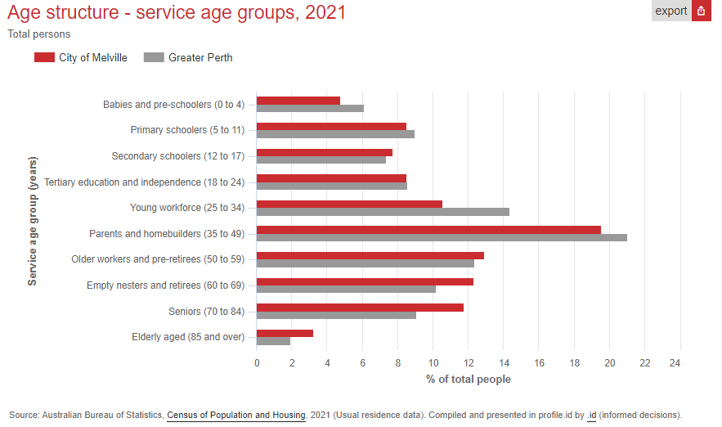

Analysis of the age data reveals the following picture:
The major differences between the age structure of the City of Melville and Greater Perth were:

- A larger percentage of 'Seniors' (11.8% compared to 9.1%)
- A larger percentage of 'Empty nesters and retirees' (12.3% compared to 10.2%)
- A smaller percentage of 'Young workforce' (10.6% compared to 14.4%)
- A smaller percentage of 'Babies and pre-schoolers' (4.8% compared to 6.51%)
- A smaller percentage of ‘Parents and homebuilders’(19.6% compared to 21%)

The City of Melville participates in the highly successful Better Beginnings family literacy program which is run under the auspices of SLWA. Every school within the City participates in the program and so despite the slightly lower than average population in this age group, junior collections experience particularly strong usage at all branches.

The slightly higher than average population of seniors is consistent with the continued strong circulation of large print books.

The largest changes in the age structure of the City of Melville between 2016 and 2021 were in the age groups:

- Seniors (70 to 84) (+2,616 people)
- Empty nesters and retirees (60 to 69) (+1,145 people)
- Parents and homebuilders (35 to 49) (+1,060 people)
- Primary schoolers (5 to 11) (+643 people)

The Aboriginal and Torres Strait Islander population in the City in 2021 was 915 people. In accordance with the City’s Stretch Reconciliation Action Plan 2017-21, the library collection aims to promote respect for Aboriginal and Torres Strait Islander culture and First Nations content for all ages is added to the collection on an ongoing basis. Further direction is taken from the Aboriginal and Torres Strait Islander Library Information Resource Network (ATSILIRN) Protocol 2: Content and Perspectives which aims to ensure “collection materials we hold by and about Aboriginal and Torres Strait Islander peoples are comprehensive, inclusive and reflect all perspectives”.

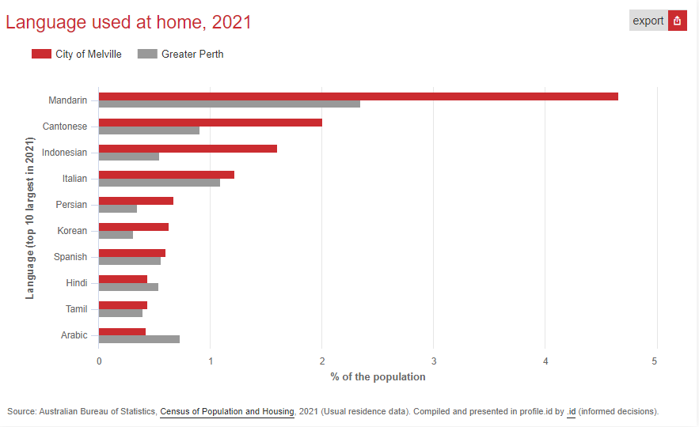

Within the City 20.3% of residents elect to speak a language other than English within the home environment, compared to 21% for Greater Perth. The following graph contains a breakdown of those languages and provides a comparison with the Greater Perth region.

The largest changes in the spoken languages of the population in the City of Melville between 2016 and 2021 were:

- Mandarin (+641 persons)
- Indonesian (+301 persons)
- Italian (-165 persons)
- Persian (+104 persons)

The collection needs of the City’s CALD community are addressed in section 7.3.

5. BACKGROUND TO THE COLLECTION
The City of Melville Library Service comprises 5 individual branch libraries. The total collection size is approximately 155,000 volumes of which 62% is SLWA funded stock and 38% locally funded. The collection serves a current active library membership of 33,627, where active membership is defined as having used library services within the last 2 years.

Collections are regularly refreshed across the library network using the principle of “floating collections” and through the regular transfer of library items between branches. The only collections that do not float are Magazines, LOTE, Junior Easy Readers and the Melville Local Authors collection which is located at the A.H. Bracks Library.

Civic Square Library
This library is centrally located within the City’s area and is adjacent to the City’s Civic Centre and the Westfield Booragoon shopping centre. It houses a mid size collection of approximately 38,000 items. Proximity to the shopping centre ensures high visitation and recent changes made to the Canning Bridge Express Library have created an increase in numbers of children attending early years programs and borrowing from the junior collections at this branch.

AH Bracks Library + Creative Space
The AH Bracks library is currently the largest branch and houses the most traditional broad-spectrum collection of approximately 63,000 items. AH Bracks offers the most weekly children’s sessions, running 4 storytime and 3 baby rhyme time sessions per week and looking to increase these offerings even further due to increased demand. The City’s Local History collection is housed at this branch. This collection is not for loan. A small, curated collection of local City of Melville resident authors is also held at this branch.

Bull Creek Library
The Bull Creek Library is in a thriving neighbourhood, adjacent to the local Stockland Shopping Centre and co-located with the Bull Creek Community Centre. After a major refurbishment in 2017, this branch now houses a physical collection of approximately 32,000 items. The Bull Creek Library community is highly multicultural and this branch supports a large Chinese-speaking membership.

Willagee Library
Willagee Library houses 15,000 volumes. This branch has an emphasis on learning and literacy and works in close partnership with local schools and the Willagee Community Centre to address the needs of young people from the local community. Willagee is the only branch to run a regular homework help program. With the support of specialist Youth Officers this branch operates as a Youth Zone after 3pm, and adults are encouraged to visit the library before this time. A major refurbishment of this library is scheduled for late 2023.

Canning Bridge Express Library
The Canning Bridge Express Library was re-opened following a long COVID closure under a new model of service delivery that sees the public areas of the space reduced in size and unstaffed. A small collection of approximately 2,000 volumes is available for loan. There are no DVDs, magazines, young adult or LOTE items. RFID technology facilitates self-service returns and checkouts. An OPAC is available to enable holds to be placed on items at other sites.

Storage Stacks
The reduced size of the public space at the Canning Bridge Express Library created an opportunity for a storage facility to house approximately 6,000 collection items at the same site. Storage items are retrievable via the catalogue. The Central Services team is located on site and therefore items can be retrieved and distributed in a timely manner.

6. SELECTION PRINCIPLES
The following principles will apply to the future development of the library collection.

6.1 Selection of library resources is based heavily on a supplier selection model with suppliers guided by detailed collection profiles. These profiles are developed with input from a variety of library staff and will include staff with specialist skills and expertise, particularly in the areas of early childhood development, language, literacy and learning. Profiles include indicators for number of duplicate copies to be purchased initially across the collection. Additional copies to meet high demand are added using discretionary funds at a copy to holds ratio of 1:5 for all formats except DVDs being 1:8. An upper limit of 8 copies is in place as a general guideline.

The Collection Development Librarian is charged with overseeing the centralized management of materials and resources across the library service. Supplier assisted selection has been in place for 10 years for locally acquired popular new release adult fiction material and has proven most effective in ensuring quality of titles and timeliness of supply. The supplier selection model was implemented in July 2018 for all SLWA funded resources. Selection profiles are to be monitored closely and as part of contractual agreement with suppliers can be altered at any time.

6.2 Material will be acquired in a range of formats including print, audio-visual and electronic. Material must be suitable for public lending purposes with consideration to appropriate distribution and licensing agreements, packaging, and presentation. Material with distribution restrictions will generally not be purchased. Only electronic resources with public lending rights will be available for loan.

6.3 Selection shall be undertaken without promoting or discouraging any particular viewpoints. Censorship shall not be undertaken, however collection items must abide by Federal and State Government decisions on banned and restricted materials (e.g. The Classification Board). While due care will be taken with regard to collection placement and layout, material will not be rejected or removed from the collection based on concerns that children may access items intended for adult use. Parents or guardians are legally and morally responsible for the suitability of materials perused or borrowed by children in their care. Every parent or guardian has the right to guide the reading, viewing, listening and playing of their children but must give the same right to other parents and guardians.

6.4 Donated material is not accepted into the collection. The only exception is for City of Melville resident authors whose donated works will be accepted for inclusion in the Melville Local Authors collection held at the AH Bracks library. Chinese language material may be donated and will be assessed for inclusion by a native speaking staff member.

6.5 Items are assessed for selection according to a number of criteria which include:
- The suitability of the item in terms of currency, accuracy, level and language
- Relevance to local lifestyles and trends
- Promotes Diversity, Equity and Inclusion (DEI)
- Publication date
- Potential use of the item, circulation of similar materials
- Composition of the collection
- Enduring value
- Professional or literary reputation of author, publisher, producer
- Reviews in professional and popular media
- Cost and availability
Suggestions for purchase from community members are very welcome. A staff mediated New Purchase Request Form on the Intranet facilitates the process of handling customer suggestions. All suggestions are considered against the principles outlined in this document. Requests for reconsideration of a selection decision must be submitted in writing to the Coordinator Library Services.

7. SPECIAL COLLECTIONS
7.1 Reference
In keeping with current trends that see traditional reference material accessed largely through online channels, the library collection no longer holds printed material in “reference” status i.e. unavailable for loan. Traditional reference material is included in electronic holdings – see 7.4. There are two small exceptions to be noted: a set of Year 11 and Year 12 ATAR Study Guides and Sample ATAR Exam Booklets are kept as reference at the Civic Square and AH Bracks Libraries. Further, two years of back issues of Choice Magazine are not for loan.

7.2 Local History
The City of Melville Local History Collection is housed at the AH Bracks Library. This collection is searchable on the library catalogue but is not for loan. This collection is managed and maintained by the Local History Officer.

7.3 Languages Other Than English (LOTE) and English as a Second Language (ESL)
The decision to select materials in Languages other than English (LOTE) is based on identified need derived from both library system data and statistics from the most recent ABS Census. As a result the Library Service currently places an emphasis on procuring LOTE resources in Chinese, French, German, Hindi, Italian, Japanese, Spanish and Tamil. Previous inclusion of Indonesian and Vietnamese material proved unsuccessful making it clear that not all CALD groups in the local community are actively seeking reading material in their native languages.

LOTE material is provided to meet the needs of all age groups. The majority of material in languages other than English is obtained from the State Library of WA and these items are regularly reviewed for usage and need and are turned over accordingly using the stock exchange process.

Language material is selected to support various programs run by the library service which currently include Bilingual Storytime sessions in Chinese and English, Noongar Language Storytime, Hindi Rhyme Time, Tamil Rhyme Time, Learn English Through Storytime (LETS) sessions, as well as Social English classes for adults.

LOTE and ESL resources can also be accessed in digital form through the various online platforms that form the eLibrary – see 7.4.

7.4 eLibrary Collection

The aim of the eLibrary collection is to provide secure access to a selection of electronic resources that supports the needs of the community 24/7. This includes access to reference material as well as downloadable content including eBooks, eAudiobooks, eMagazines, eVideos and information databases.

The SLWA provision of downloadable collections through the WAPLDMC (WA Public Library Digital Media Collection) continues to grow. A thorough review of locally acquired eResources, which includes a cost-per-use analysis, is conducted on an annual basis. Language Resources and Online Newspaper services are consistently the strongest performers. This review further ensures an appropriate balance is maintained between SLWA and locally acquired digital resources. The growing strength of the WAPLDMC collection has reduced the need for local acquisition to some degree. Resource sharing with other LGAs is seen as a positive way forward for locally acquired eLibrary content. The WA ePlatform Consortium was established in 2018 and comprises Mandurah, Kwinana and Melville LGAs.

The State Library of WA provides an excellent range of online resources which includes scholarly databases for study and research, as well as a large collection of predominantly non-fiction eBooks. Licensing restrictions unfortunately prevent access to some of these items from within local government facilities. Members of the public with home Internet access should be encouraged to access these resources by obtaining an SLWA library card. The City of Melville collection will not duplicate these resources in the local collection.

The inability to integrate catalogue records for digital titles is regarded as an inhibitor to access. Currently most eBook and eAudiobook titles are integrated into the Enterprise catalogue. Hoopla titles are not included as the enormous number of records would be overwhelming to the catalogue. Further work is needed to include eVideo and eMagazine titles.

It should be noted the City of Melville Libraries has no access to settings controls for electronic resources provided under the WAPLDMC arrangement. The setting of user access parameters is controlled by the State Library of Western Australia.

8. LIMITATIONS
As a result of the shift towards digital formats and streaming services, the collection no longer includes music CDs.

The allocated funding for the DVD collection will also be reduced over the coming years. As a result of the increased pressure inter-library lending restrictions have placed on our local purchasing processes a decision has been taken not to start collecting any new DVD series moving forward. DVD series items are available for inter-library lending after the initial 12-month restriction period, so we will be relying on ILL for series and focusing our collection on movies or mini-series which are based on books, have won awards, or represent diverse cultures, such as world and festival films.

The physical magazine collection is also being affected by the shift to digital content with numerous titles ceasing publication in physical form each subscription year. The current collection is heavily duplicated across the physical and digital format with an ever-increasing number of print titles available on one or all the expanding number of eMagazine platforms.

Similarly, the demand for audiobooks in CD/MP3 format has significantly waned in response to the global uptake of digital eAudiobooks, and some publishers of audio content are reducing the range of titles released in physical format. This collection will reduce in size noticeably in coming years.

Self-published works will generally not be collected unless of a significant local relevance.

School, TAFE and university text-books will not generally be collected.

9. COLLECTION EVALUATION
Collection evaluation is an essential exercise that will inform decisions of both selection and de-selection. Collection analysis strategies will identify collection strengths and weaknesses and help avoid unnecessary duplication across branches. Some of the methods employed will include:

- Overall circulation data trends
- Turnover rates
- Snapshot of on loan / on shelf ratios
- Collection age
- % of collection items borrowed within a year of acquisition
- Interlibrary loan request data
- Community consultation

Stock-takes are also conducted to ensure the integrity of the library catalogue. The timing of stock-takes is usually linked to refurbishment and other building projects within the service.

The library subscribes to an evidence-based stock management application, collectionHQ, which is used to inform selection and analyse performance.

10. DESELECTION AND DISPOSAL
It is necessary to delete items from the collection on an ongoing basis in order to maintain the currency, quality and relevance of material held. De-selection or weeding of the collection is undertaken at the direction of qualified staff.
Common criteria for de-selection include:
- Poor physical condition
- Limited usage
- Superseded editions
- Duplicates no longer in high demand
- Incomplete sets or series where the missing components are no longer available
- Redundant formats
- Irrelevant to current needs
Magazines are treated under a specific retention schedule as outlined in the table below.
Weekly magazine | Retain for 6 months
Fortnightly magazine | Retain for 1 year
Monthly magazine | Retain for 2 years
Quarterly magazine | Retain for 3 years

Material that is withdrawn from stock due solely to poor physical condition may be replaced if it is a standard work, a popular title or subject.
Discarded stock may be sold at an in-house book sale, offered to other community organisations, offered to other library services or recycled.

11. Complaints or challenges
It should be noted that City of Melville Libraries has a right and duty to keep on its shelves a representative selection of materials. These materials will cover topics of interest to its readers which are not prohibited by law and may include a range of opinions and controversial subjects. Patrons may from time to time bring to the attention of library staff material they think should not be part of the library collection. In these instances, a formal request must be made in writing and submitted to the Coordinator Library Services using the Request for Reconsideration of Library Material Form available in all library branches. This form is available as a physical form only and requests will be accepted from current library members only. All accepted requests will be assessed in accordance with the Request for Reconsideration of Library Material Guidelines.
Materials will not be rejected on moral, political, racial, or religious grounds if they otherwise meet selection criteria. A perception that material may offend or cause controversy to a person or a group of people is not, of itself, a reason to limit purchase or provision of an item containing that material.
Parent/guardians are legally and morally responsible for items borrowed and accessed by children in their care. They have the right to guide the reading, viewing, listening and playing of their children but must give the same right to other parents.

SCOPE
These guidelines apply to all Council staff and Council contractors involved in the selection, acquisition, maintenance and weeding of items in the library collection.

RELATED POLICIES / LEGISLATION

CP-023 Procurement of Goods or Services

REPORTING REQUIREMENTS

Library Board of Western Australia Act 1951

WA Public Libraries Strategy: a new chapter for our Public Library System

APLA / ALIA’s Standards and Guidelines for Australian Public Libraries May 2021

RELATED DOCUMENTS
Australian Library and Information Association (ALIA) Statement on public library services

Australian Library and Information Association (ALIA) Statement on free access to information
Australian Library and Information Association (ALIA) and Australian Public Library Alliance (APLA) Joint Statement on free access to information in Australian libraries
Australian Library and Information Association (ALIA) Statement on information literacy for all Australians

Australian Library and Information Association (ALIA) Statement on libraries and literacies

Australian Library and Information Association (ALIA) Library and information services and Indigenous peoples

Australian Library and Information Association (ALIA) Library and information services for people with a disability

Australian Library and Information Association (ALIA) Guidelines for Australian home library services

Australian Library and Information Association (ALIA) ALIA Statement on online content regulation

Australian Library and Information Association (ALIA) ALIA position statement on ebooks and elending, September 2017

IFLA-UNESCO Public Library Manifesto 2022

State Library of NSW. Indigenous Spaces in Library Places

SUPPORTING DOCUMENTS
Request for Reconsideration of Library Material Form

Request for Reconsideration of Library Material Guidelines

RESPONSIBILITIES

Compliance with the provisions of these guidelines, and any attached guidelines/templates, is mandatory
Appendix A

Physical collection definitions

Adult Fiction
Aimed at a diverse adult audience, this collection is a mix of contemporary and classic titles across multiple genres. These titles may contain adult themes and content including strong language, sexual themes, drug reference, horror and violence.

Large Print
This collection meets the needs of the members of the community unable to read standard sized print materials. The collection is aimed at a diverse adult audience and is a mix of contemporary and classic titles across multiple genres. These titles may contain adult themes and content including strong language, sexual themes, drug reference, horror and violence.

The Large Print collection contains adult fiction and adult non-fiction material.

Adult Non-Fiction
Aimed at a diverse adult audience. The collection is fact based and provides access to current and accurate information resources across a wide range of subject matter.

Biographies
Aimed at a diverse adult audience, this collection is written about or by real people. A wide range of themes from around the world including historical events, people and experiences are explored in this collection.

Young Adult Fiction
Aimed at a diverse range of young people between the ages 12 to 18. The collection is spread between two age groupings physically identifiable by spine labelling as defined below:

YA-JF
Material with mature themes and content which young people aged between 12 and 15 can understand. Themes including personal, social, emotional issues, death and suicide are explored with moderate impact. Readers of this collection may encounter scenes of moderate violence, sexual practises, horror, and gender issues.

YA-AF
Material with mature themes and content which young people aged from 16 and above can understand. Themes including personal, social, emotional issues, death, suicide and abuse are explored with strong impact. Young adult readers of this collection may encounter scenes of strong violence, bullying, sexual practices, horror, and gender issues.

Young Adult Non-Fiction
Aimed at a diverse range of young between the ages of 12 to 18. The collection is fact based and provides access to current and accurate information resources
across a range of subject matter. The collection focuses on social, emotional, health, gender and sexuality issues in a manner easily understood by young adults.

Study guides to support Western Australian Certificate of Education (WACE) exams are also part of the Young Adult non-fiction collection.

Young Adult Graphic Novels
Visual based novels in which much of the story is told through imagery, often from culturally diverse backgrounds. The collection is spread between two age groupings physically identifiable by spine labelling. Items are classified by the same guidelines as the broader Young Adult Fiction collection as listed above.

Adult Graphic Novels
Visual based novels in which much of the story is told through imagery, often from culturally diverse backgrounds. This collection is aimed at a diverse adult audience and is a mix of contemporary and classic titles across multiple genres. These titles may contain adult themes and content including strong language, sexual themes, drug reference, horror and violence.

Junior Fiction
Ideal for children aged between 5 to 11 years of age who are reading independently. Junior fiction books often contain a chapter-based structure engaging children with diverse themes such as the world around us, friendship, families, fantastical worlds and adventure in a manner able to be understood by primary school aged children.

Junior Non-Fiction
Suitable for children aged 5 to 11 years of age. The non-fiction collection is fact based and provides access to current and accurate information resources across a wide range of topics to help children engage with the world around them.

Easy Readers
Suitable for children learning to read, typically aged from 5 to 8 years of age. Easy Reader series have been professionally crafted to facilitate children to master reading.

The collection also caters for older readers struggling to master reading through certain specifically designed series. These books are visually distinctive with imagery more suited to older readers. Though having similar reading levels as other series in the collection, these specific older series carry more complex themes suitable for older children.

Board Books
Ideal for babies from birth to 2 years. These durable, cardboard books generally have colourful, bright illustrations and are often textured with only a few words per page. Board Books introduce babies to reading and diversity through concepts such as colours, shapes, words and counting.

Junior Kindergarten Picture Books
Suitable for children from 3 to 6 years of age. These highly illustrated books engage children visually with songs, sounds, rhyming and narration. Each page contains a few sentences with much of the story being conveyed visually.

Picture books explore a diverse range of themes including families, routines, animals, emotions and the world around us in a manner able to be understood by young children.

End of Document

